**Choosing a Resort for Stay**

Table of Contents

1. Introduction 1

2. Data 1

3. Methodology 3

4. Analysis 3

5. Results and Discussion 5

6. Conclusion 6

**1. Introduction**

**Kodaikanal** is a hill town in the southern Indian state named Tamil Nadu. It’s set in an area of granite cliffs, forested valleys, lakes, waterfalls and grassy hills making it a tourist choice with its scenic beauty. Since there are lots of resorts in Kodaikanal, we will try to detect locations that are optimal for travelers with various interests. Some tourists may like resorts closer to the town, some may like resorts closer to tourist spots and so on. We will provide the details of each location so the tourist can choose the resort of their choice.

In this project we will try to find an optimal resort of a tourist choice in a tourist place named *Kodaikanal, TamilNadu* in India.

## 2. Data

Following data sources will be needed to extract/generate the required information:

* Resorts in Kodaikanal are obtained using Foursquare API
* The details of the resort like the Rating, Number of Likes are obtained using Foursquare premium API
* Number of restaurants, tourist spots and their type and location near every Resort around 2.5 km radius will be obtained using Foursquare API

The factors that will influence our decision are:

* Venues Close by the resort – Venues could be shopping areas, other tourist spots, forest
* Ratings on the Resort – Ratings given to the resort by others and available in Foursquare
* Likes on the Resort – Number of likes on the Resort given by other visitors of the Resort and available in Foursquare

We have the list of hotels below that are fetched from the Kodaikanal area. The list has the venue Id and the Latitude and longitude of the Resorts

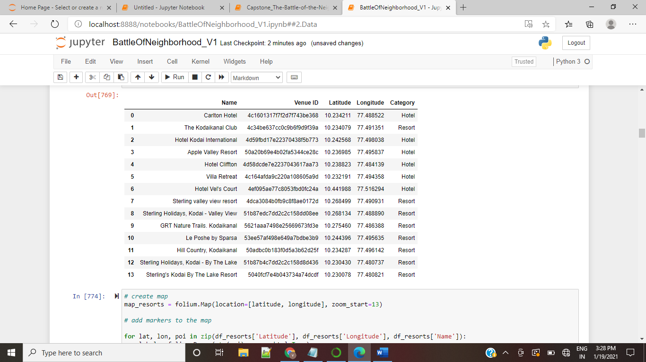

The Map below shows the location of the resorts available in Kodaikanal as per the list above

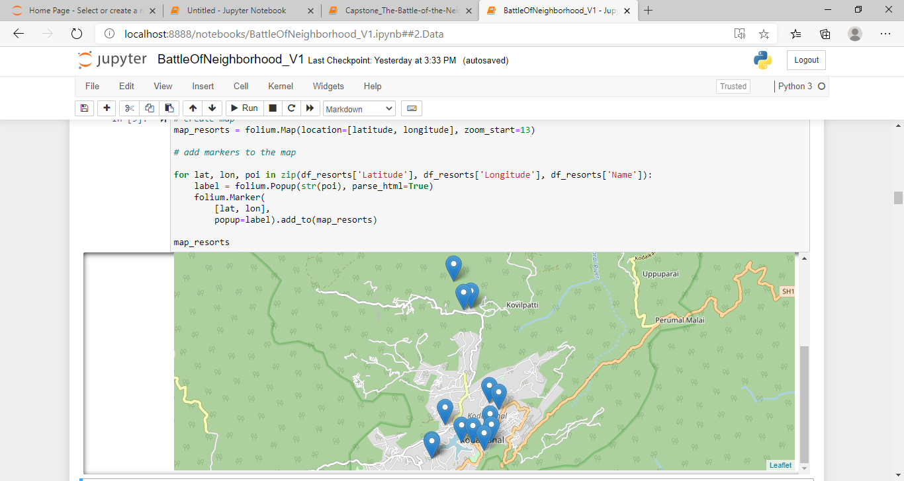

## ****3.Methodology****

In this project we are working towards helping a tourist to choose a correct resort of his taste for a stay in Kodaikanal.

To achieve this, we have taken the resorts available in Kodaikanal within 30 kms and added the venues nearby those resorts within 3 kms vicinity. We have also added the Ratings and Likes on the Resort to help the tourist to have an idea on the resort based on others review.

With all these details we have grouped the resorts into clusters using K-means clustering methodology.

## ****4.Analysis****

Adding the Rating and number of likes on the resorts using the Foursquare API. Analyzing the resorts with the details of venues nearby with the help of Foursquare API. Grouping the venues with the venue details, Rating and Likes

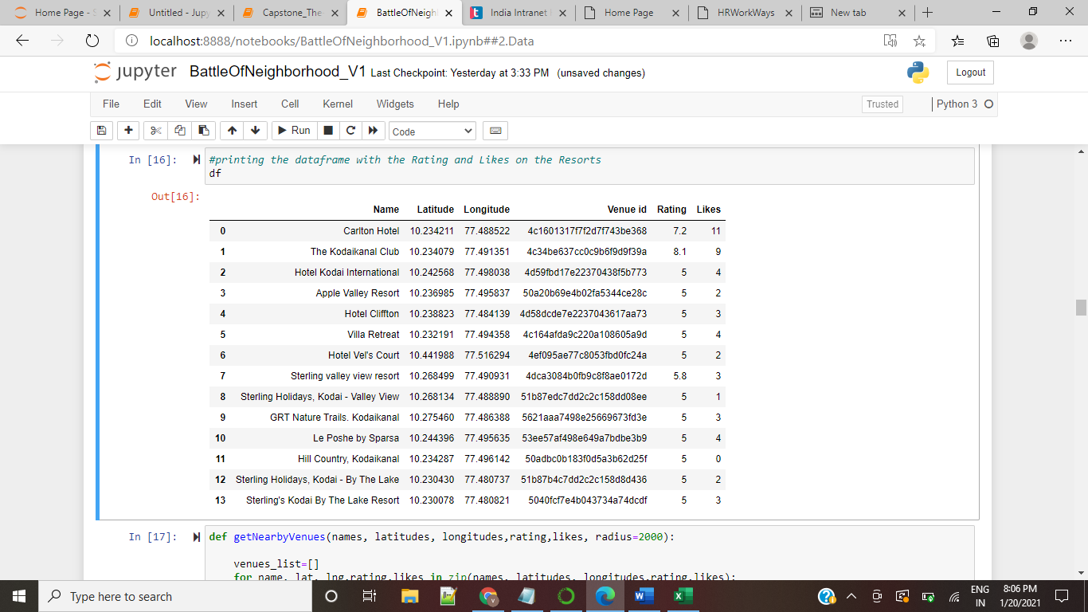

The below table shows us the resorts with number of venues nearby the resorts within a radius of 2.5 Km

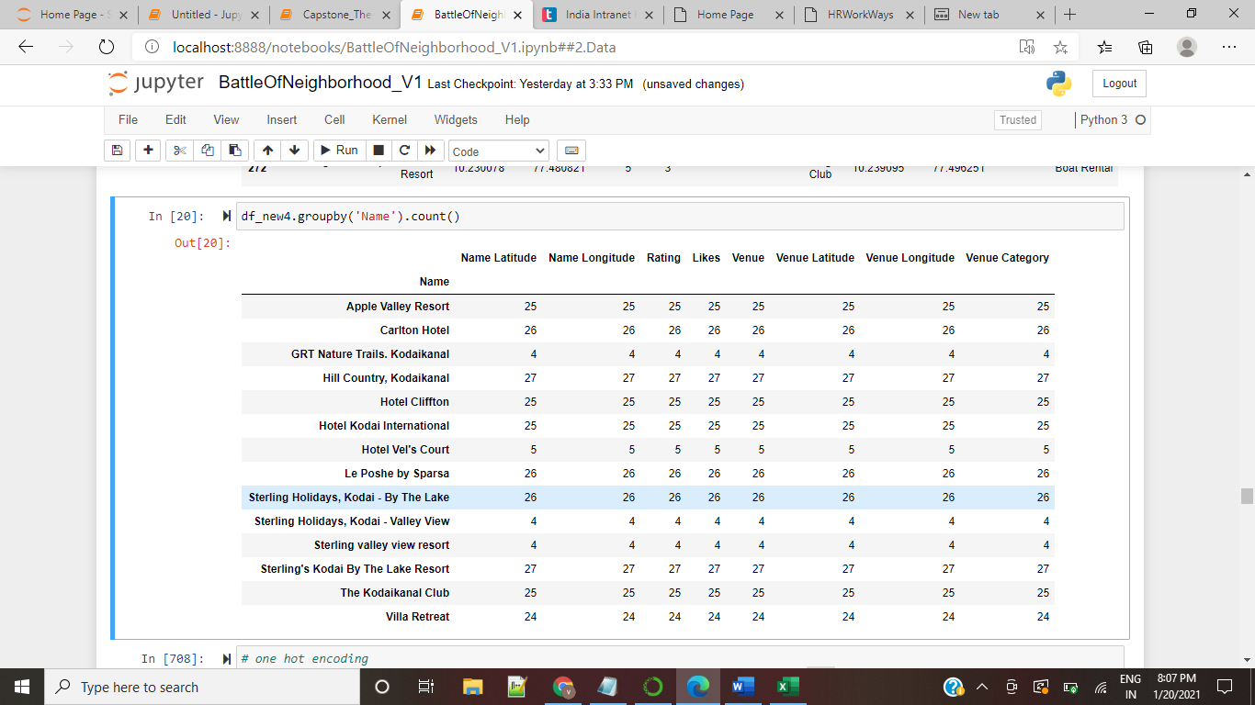

The below table shows the resorts with the 10 top most venues used by the visitors around the resorts

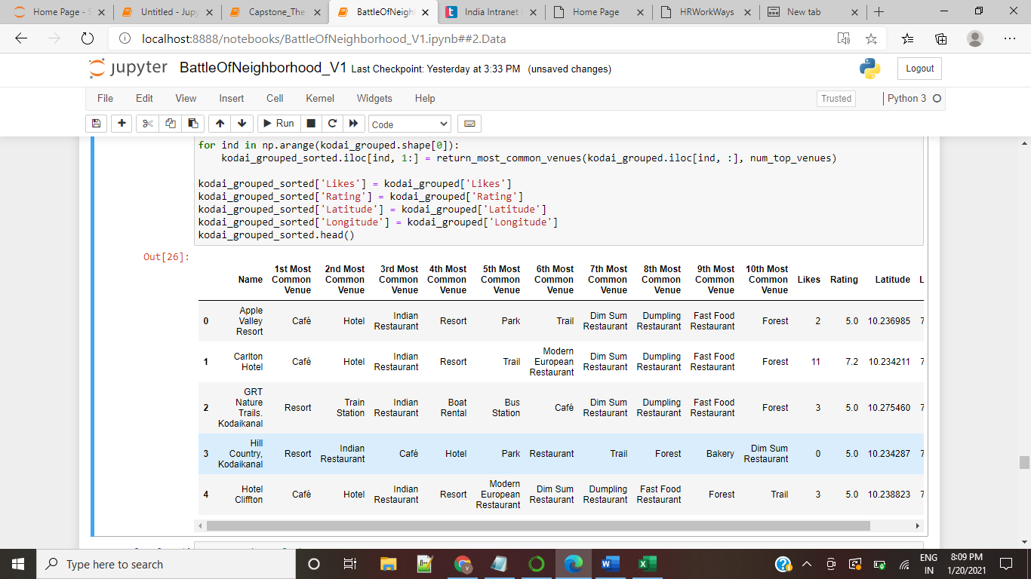

They are grouped into clusters using the K-Means clustering. There are three clusters as shown in the Map below. Red circle denotes the Cluster 0, Blue Circle denotes the cluster 1 and green circle denotes Cluster 2

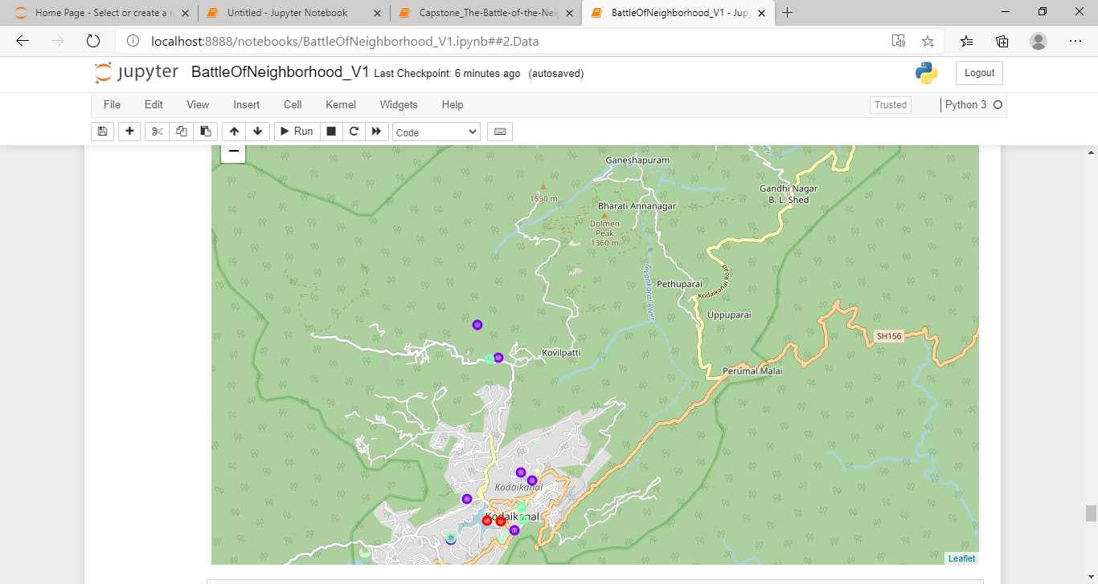

Cluster 0

Cluster 1

Cluster 2

## 

## ****5.Results and Discussion****

Based on the clustering results we have the following observation Cluster 0 - Has resorts that has number of likes greater than 5 and rating greater than 5 and few restaurants nearby. We have 2 resorts in this cluster.

cluster1 - Has resorts that has number of likes lesser than 5 and greater than 3 with a mix of nearby venues like park, boat rental, restaurants and forest. We have 7 resorts in this cluster

cluster 2 - Has resorts that has number of likes lesser than 5 with a mix of nearby venues like park, boat rental, restaurants and forest. we have 5 resorts in this cluster

## ****6.Conclusion****

Tourists who like to be in resorts with greater number of likes and that are not close to any other tourist venues can choose a resort from cluster 0. Tourists who like to be in resorts near to tourist venues with greater number of likes can choose a resort in cluster 1 and Tourists who likes to be in resorts near to tourist venues and does not worry about number of likes can choose a resort in cluster 2.